1. **Accounting Setups**

**(General Ledger > Setup > Financials > Accounting Setup Manager > Accounting Setups)**

TAB -> Legal Entities

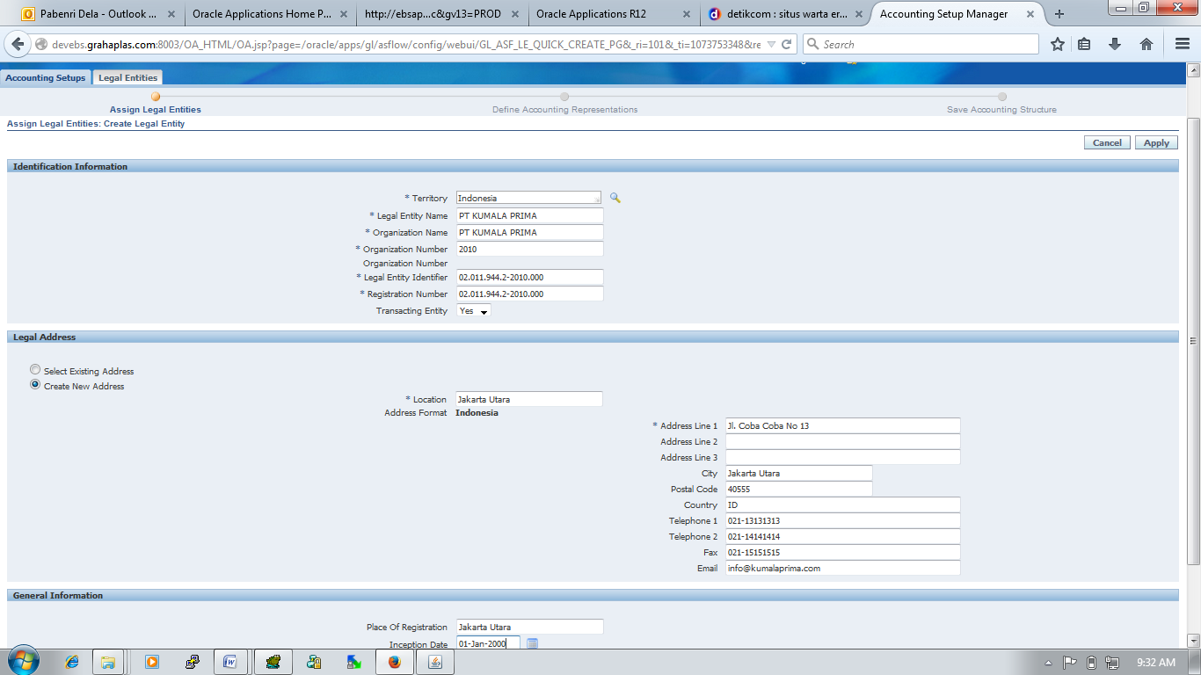

|  |  |  |
| --- | --- | --- |
| Territory | : | Indonedia |
| Legal Entity Name | : | PT KUMALA PRIMA |
| Organization Name | : | PT KUMALA PRIMA |
| Organization Number | : | 1080 |
| Legal Entity Identifier | : | 02.011.944.2-441.000 |
| Registration Number (RN) |  | 02.011.944.2-441.000 |
| Transacting Entity |  | Yes |

TAB -> Accounting Setups

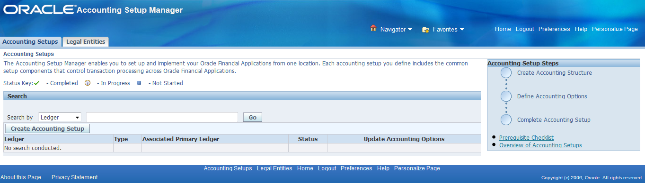

Button -> Create Accounting Setup

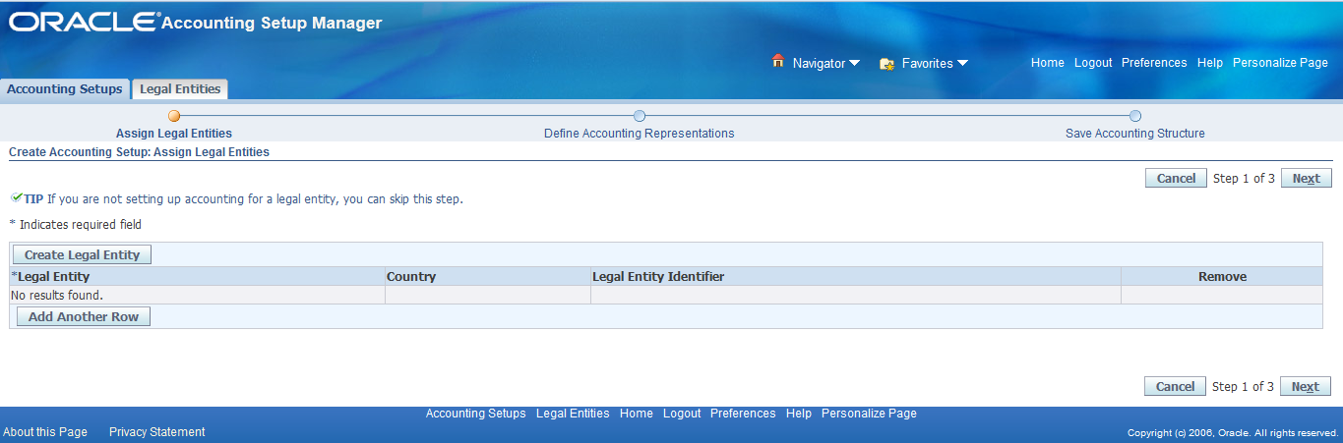

Button -> Next

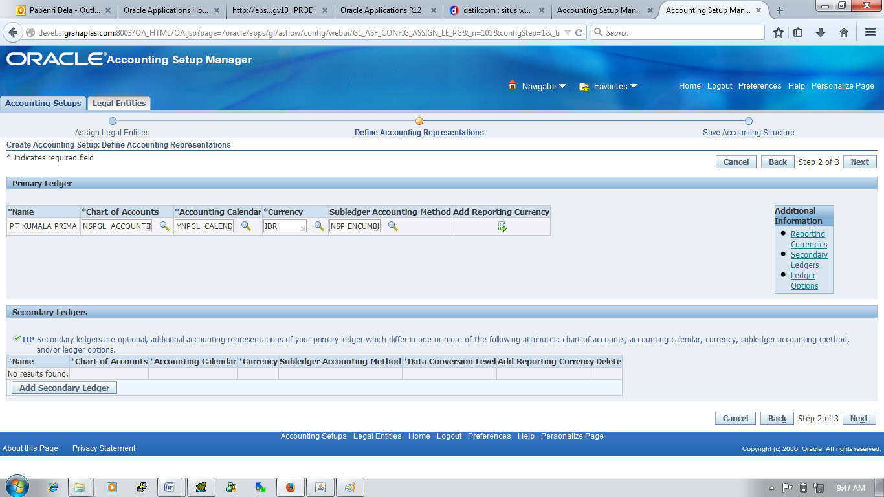

|  |  |  |
| --- | --- | --- |
| Name | : | PT KUMALA PRIMA |
| Chart of Account | : | NSPGL_ACCOUNTING_FLEXFIELD |
| Accounting Calendar | : | YNPGL_CALENDAR |
| Currency | : | IDR |
| Subledger Accounting Method | : | NSP Encumbrance Accrual |

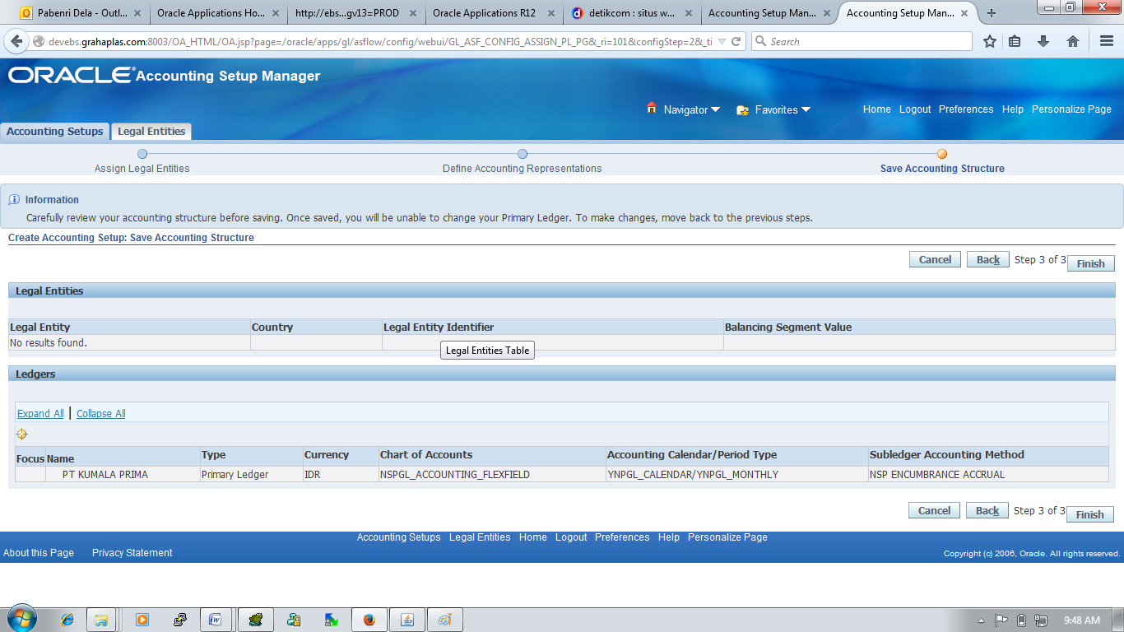

Button -> Finish

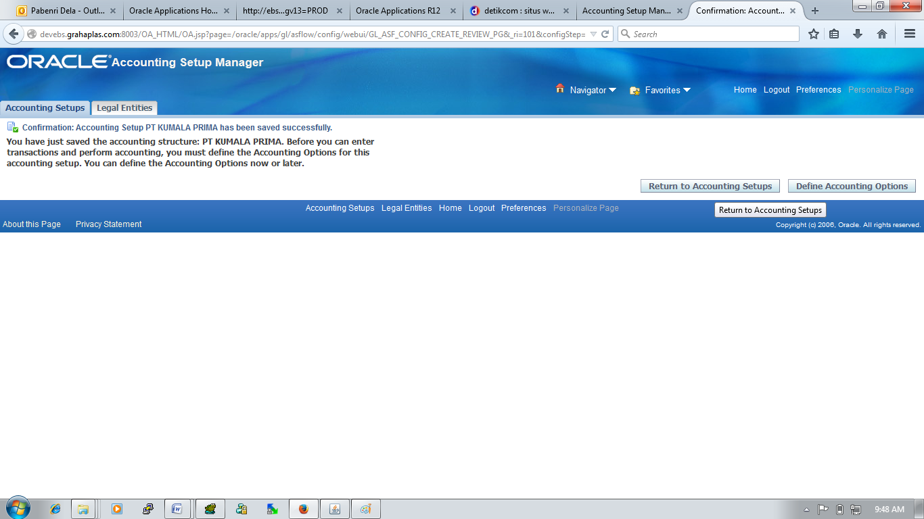

Button -> Return to Accounting Setup

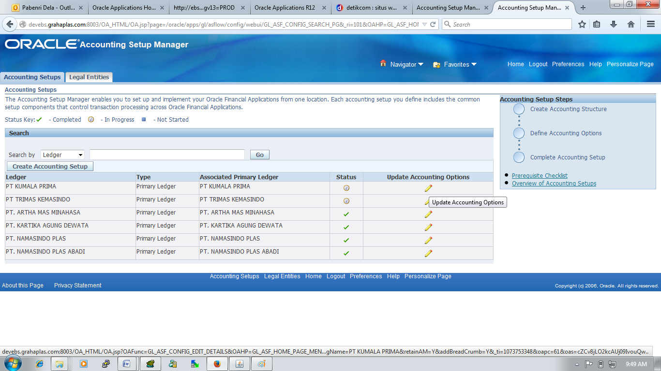

Button -> Update Accounting Options

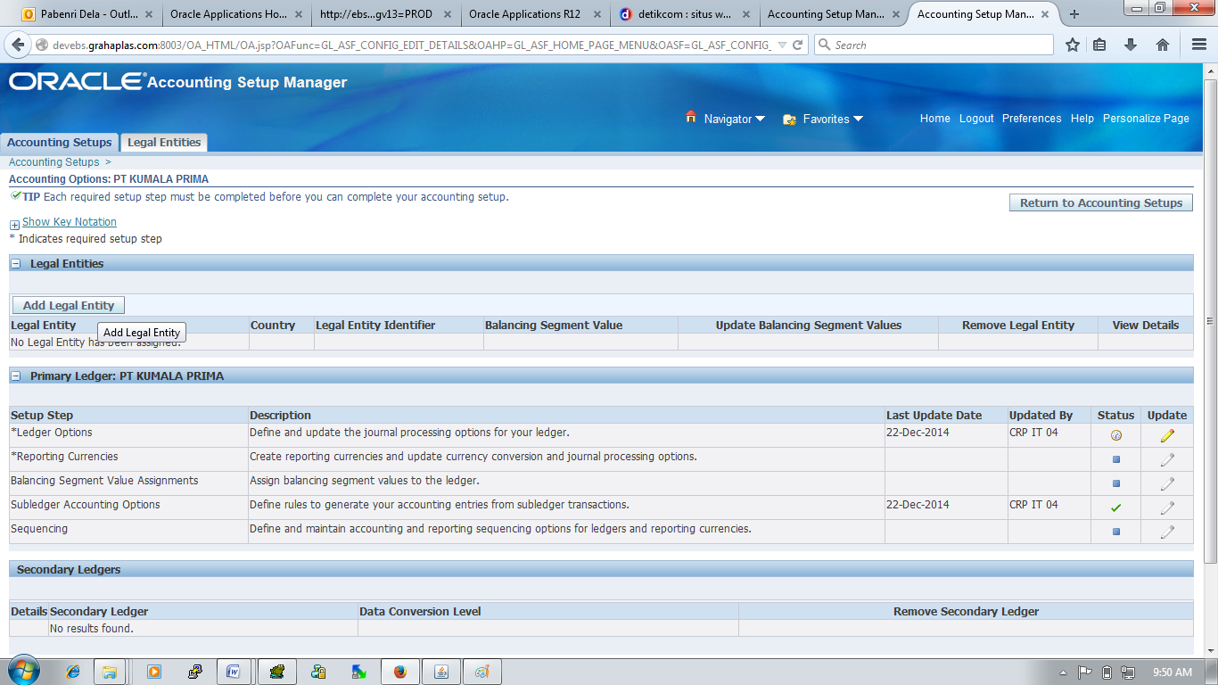

* Button -> Add Legal Entity

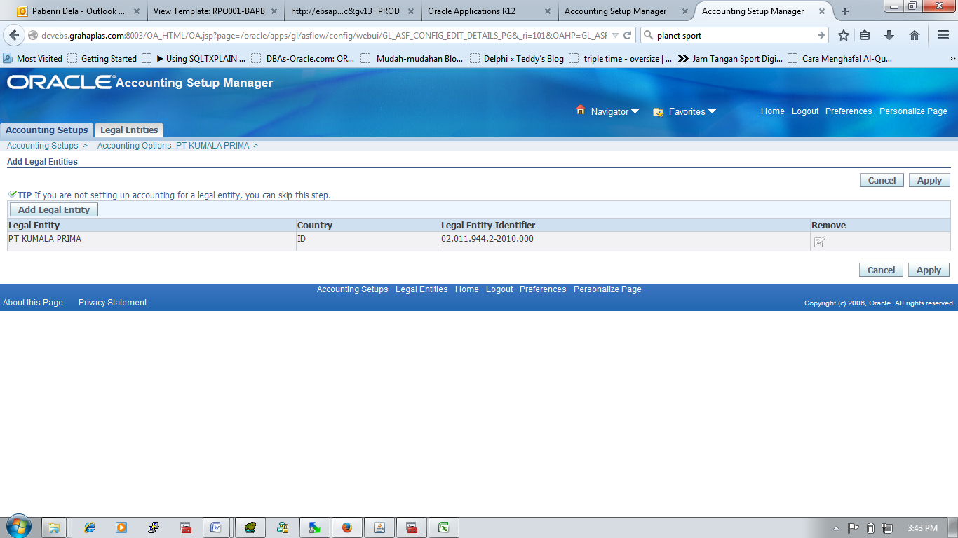

* Update (*Ledger Options) -> Update -> Complete

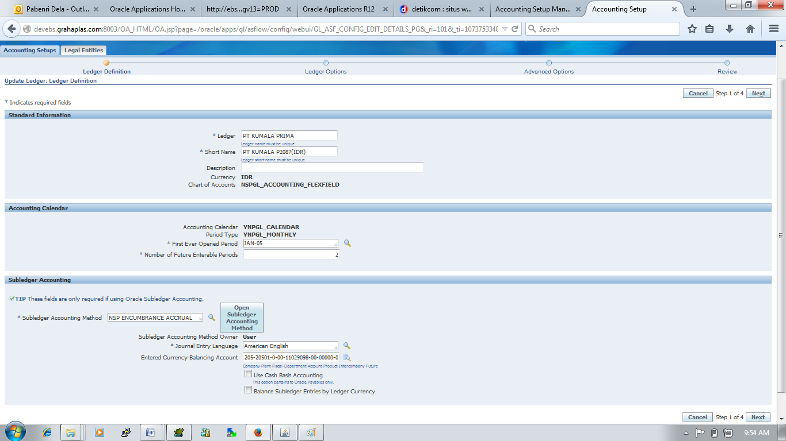

|  |  |  |
| --- | --- | --- |
| Number of Future Enterable Periods | : | 2 |
| Entered Currency Balancing Account | : | 101-10101-0-00-11029098-00-00000-00 |
| Use Cash Basis Accounting | : | Disabled |
| Balance Subledger Entries by Ledger Currency | : | Disabled |

Button -> Next

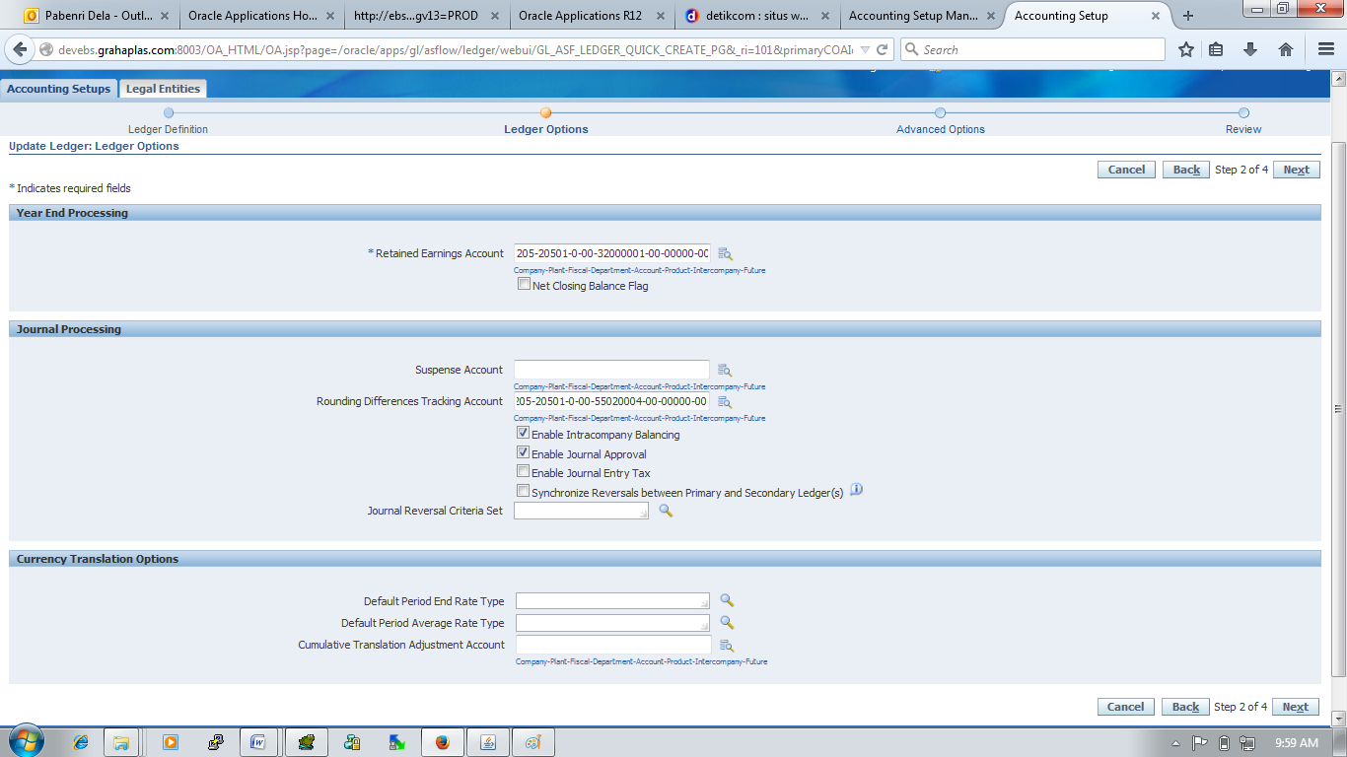

|  |  |  |
| --- | --- | --- |
| Retained Earnings Account | : | 101-10101-0-00-32000001-00-00000-00 |
| Rounding Differences Tracking Account | : | 101-10101-0-00-55020004-00-00000-00 |
| Enable Intracompany Balancing | : | Yes |
| Enable Journal Approval | : | Yes |
| Enable Journal Entry Tax | : | No |

Button -> Next

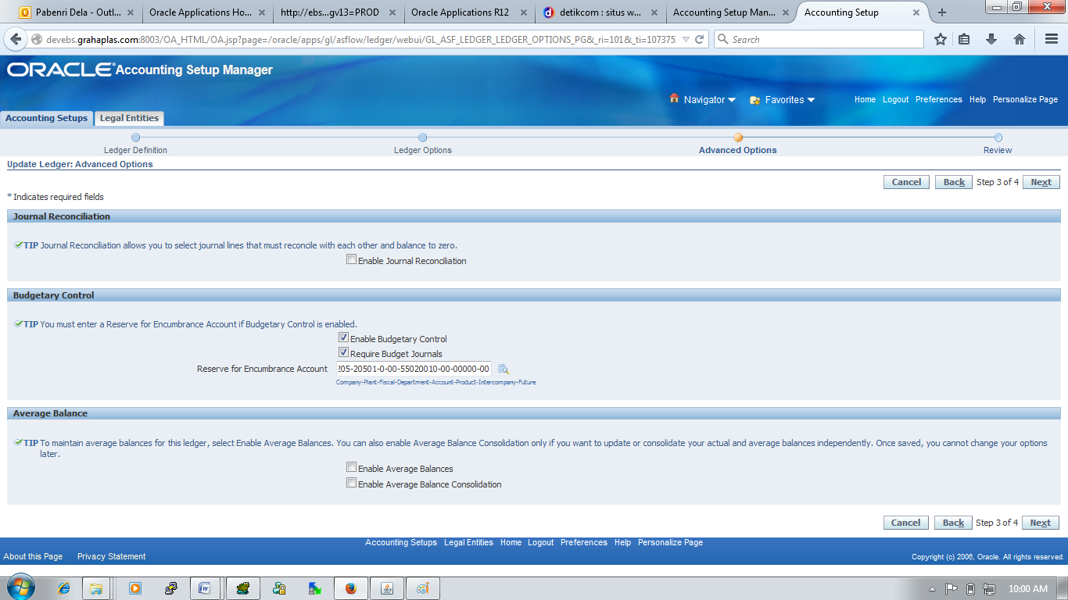

|  |  |  |
| --- | --- | --- |
| Enable Journal Reconciliation | : | No |
| Enable Budgetary Control | : | Yes |
| Require Budget Journals | : | Yes |
| Reserve for Encumbrance Account | : | 101-10101-0-00-55020010-00-00000-00t |

* *Reporting Currencies -> Update -> Complete
* Balancing Segment Value Assignments

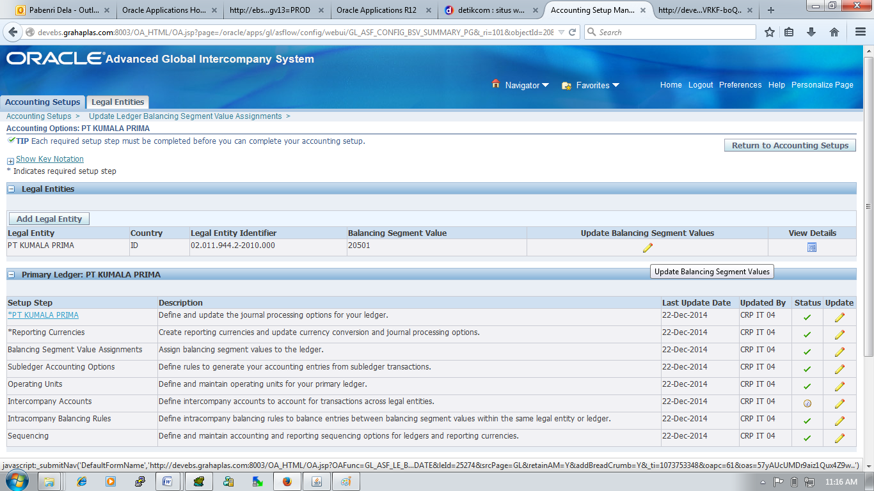

Button -> Update Balancing Segmet Value

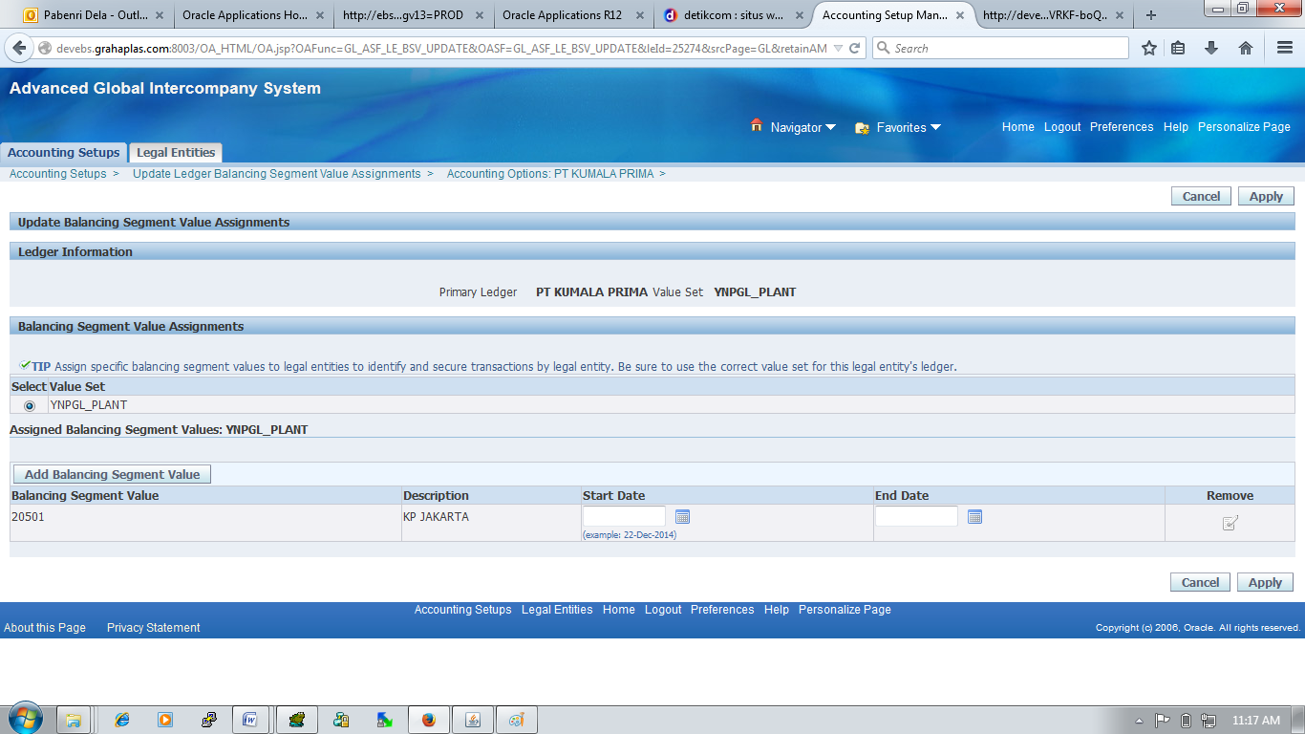

* Button -> Add Balancing Segment Values (Pilih Sesuai LE)
* Button -> Apply
* Subledger Accounting Options -> Update -> Complete
* Operating Units -> Update -> Complete
* Intercompany Accounts (sebelum setting ini harus di complete dulu untuk di Accounng Setup)

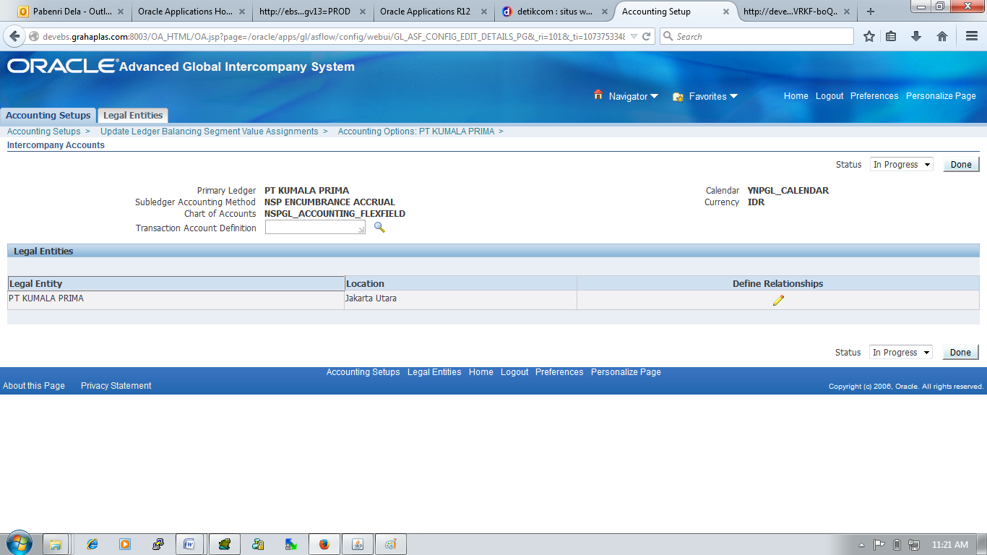

* Button -> Define Relationship

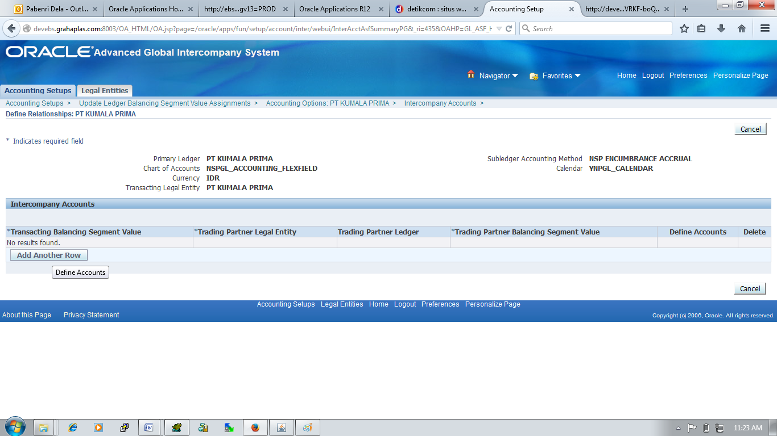

* Button -> Add Another Row

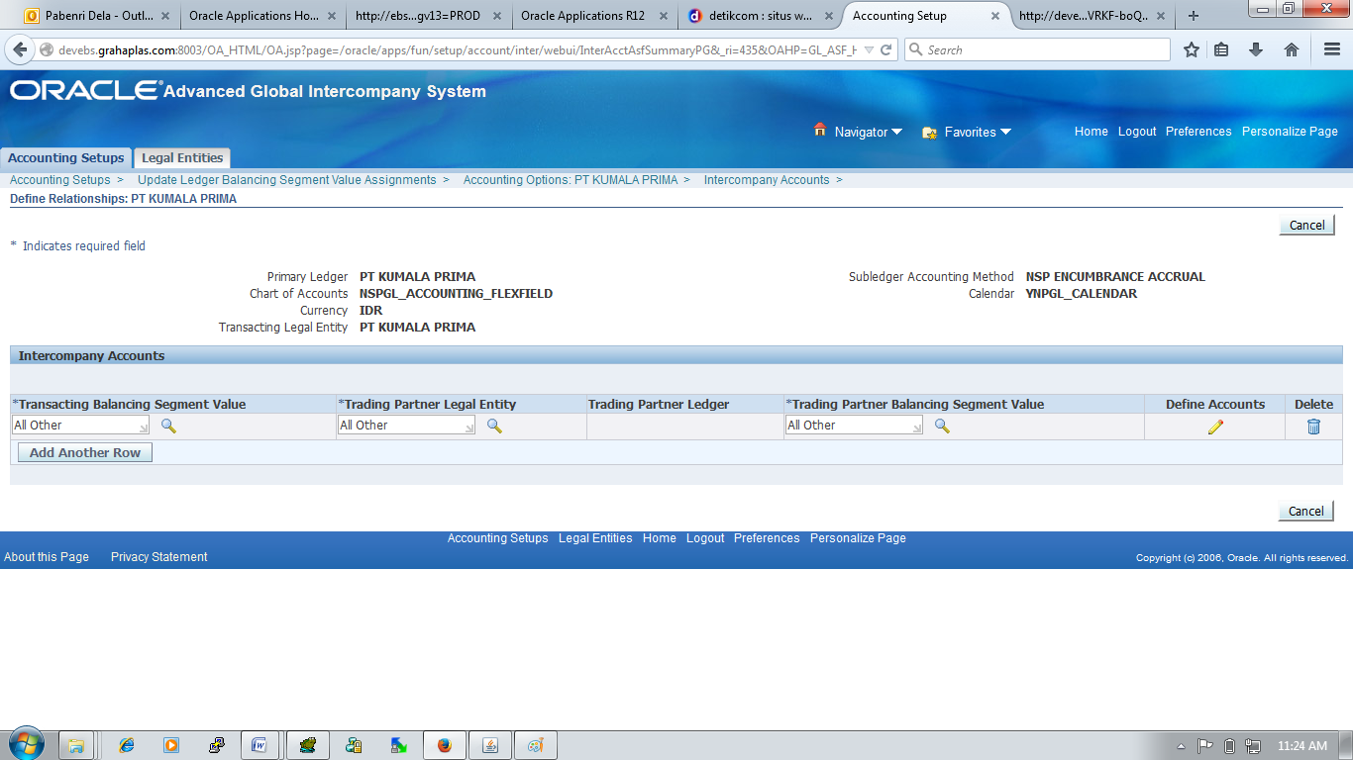

* Button -> Define Account

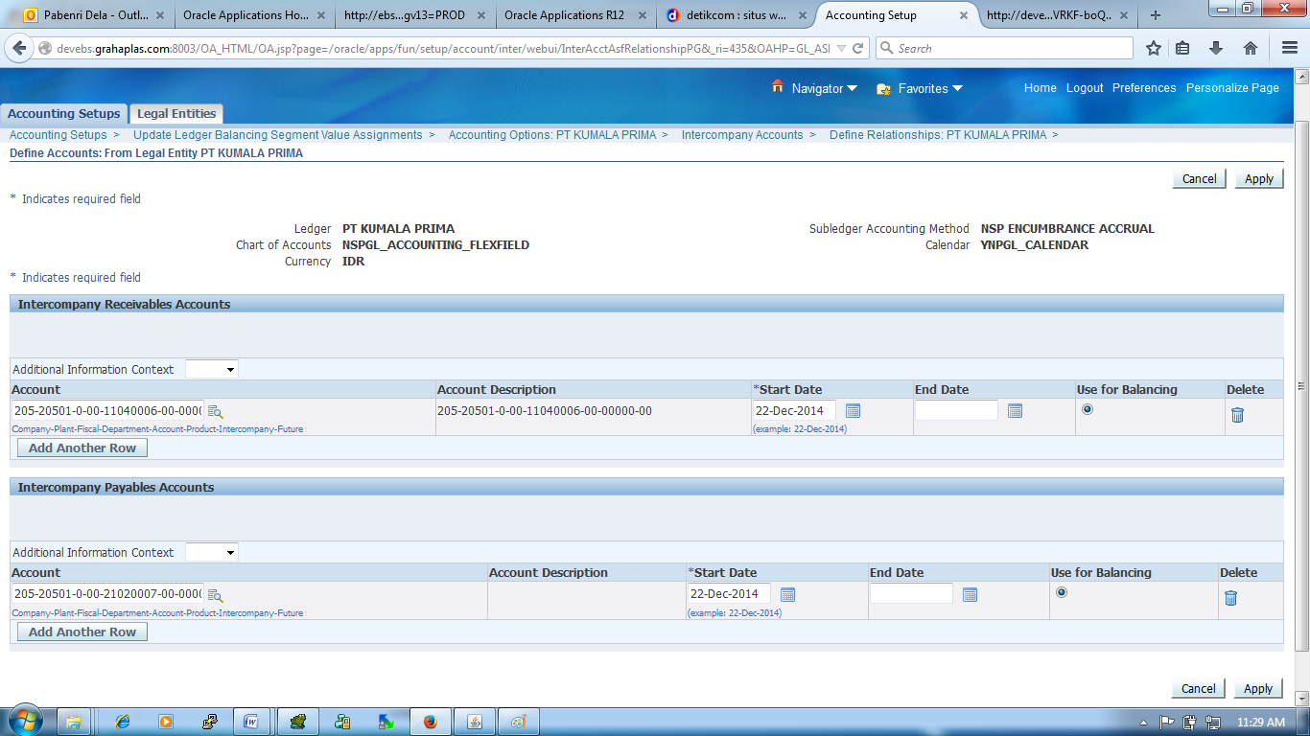

Button -> Apply

* Intracompany Balancing Rules -> Update -> Complete
* Sequencing -> Update -> Complete
* Balancing Segment Value Assignment
* Intracompany Balancing Rules

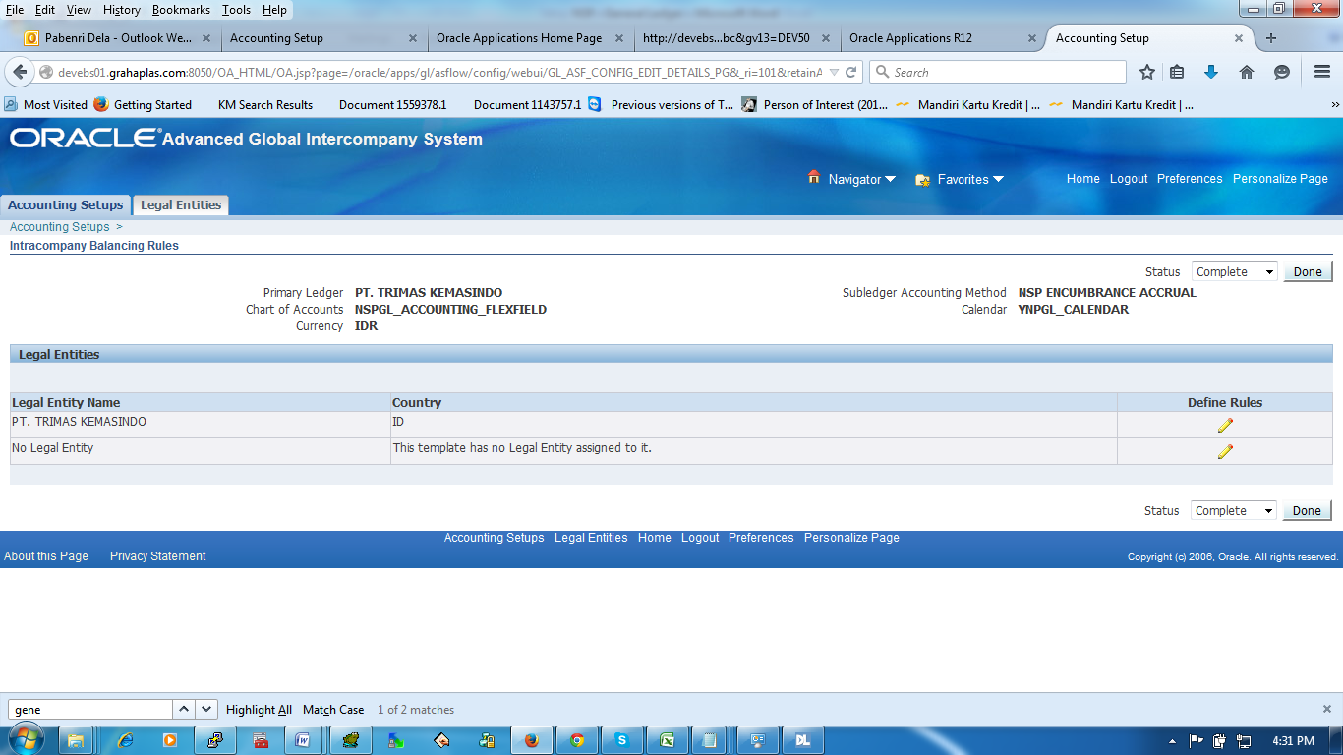

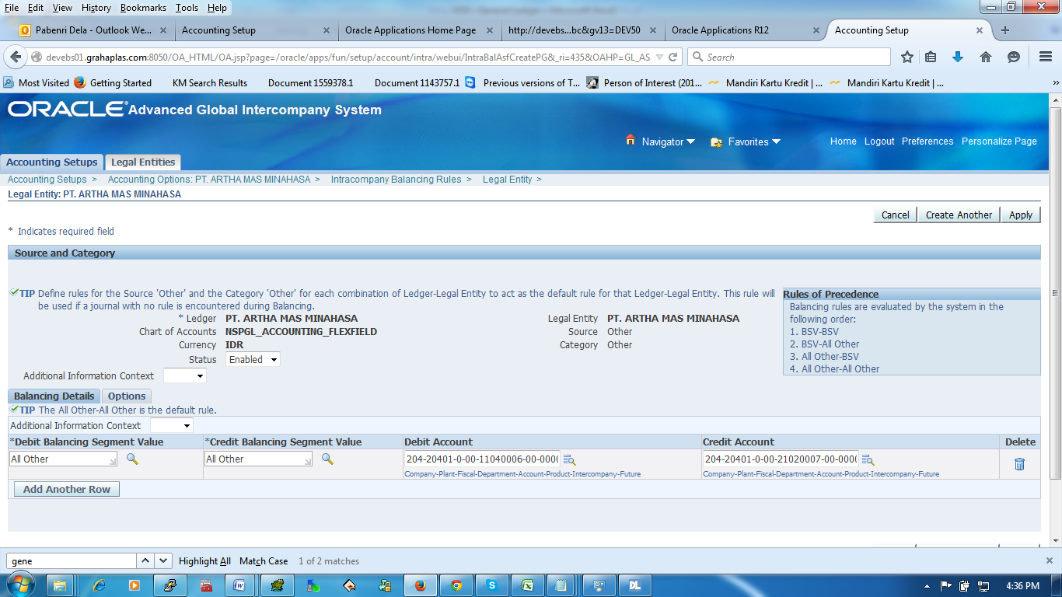

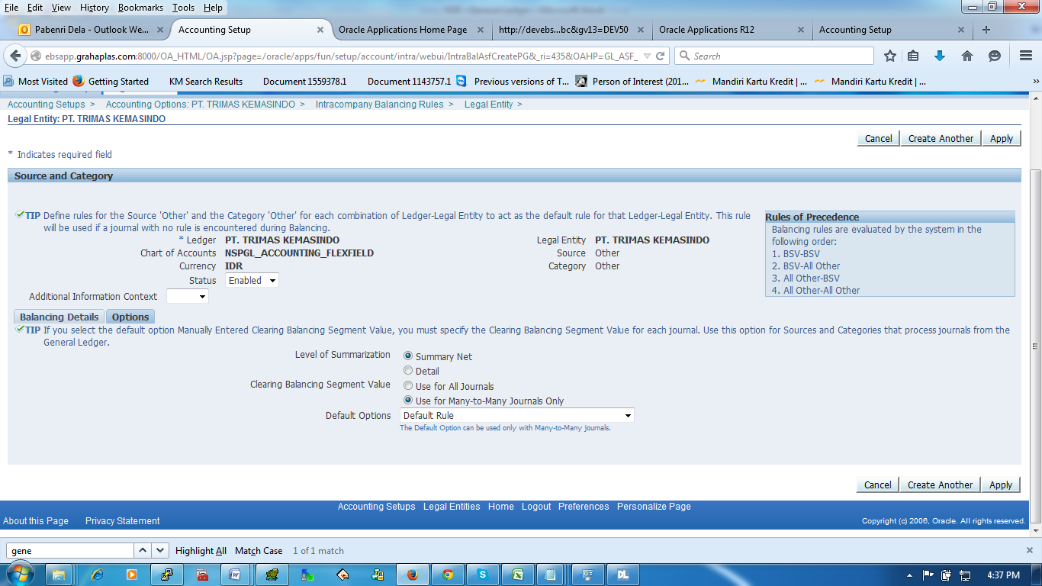

* Budget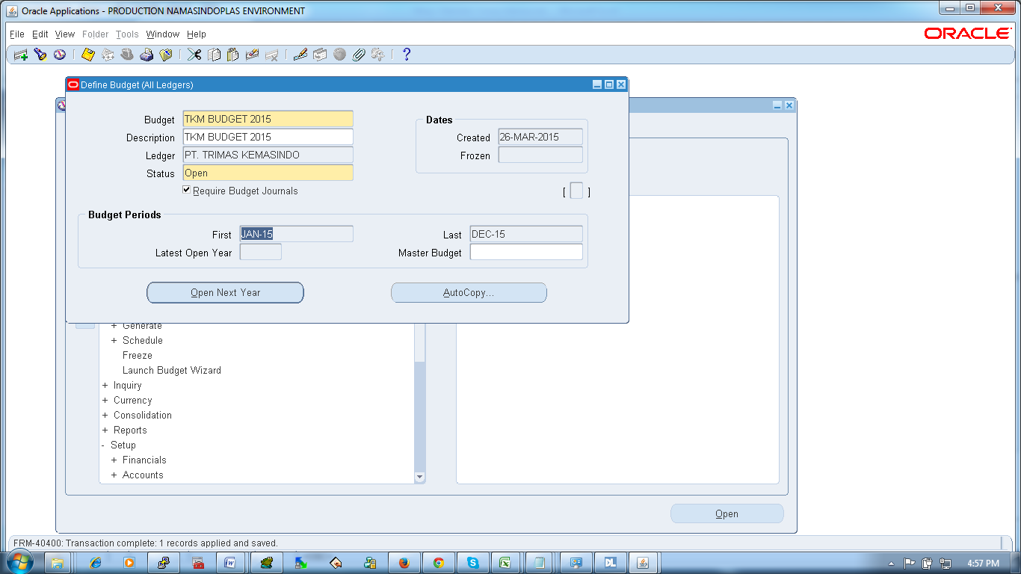
* dssdsdsd

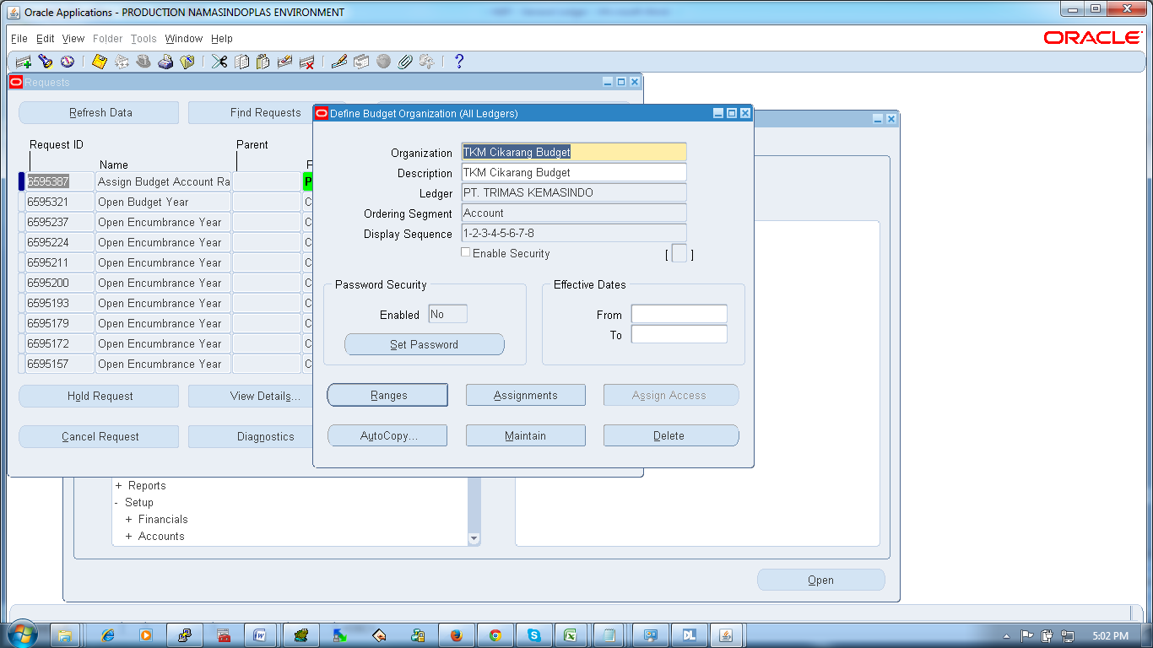

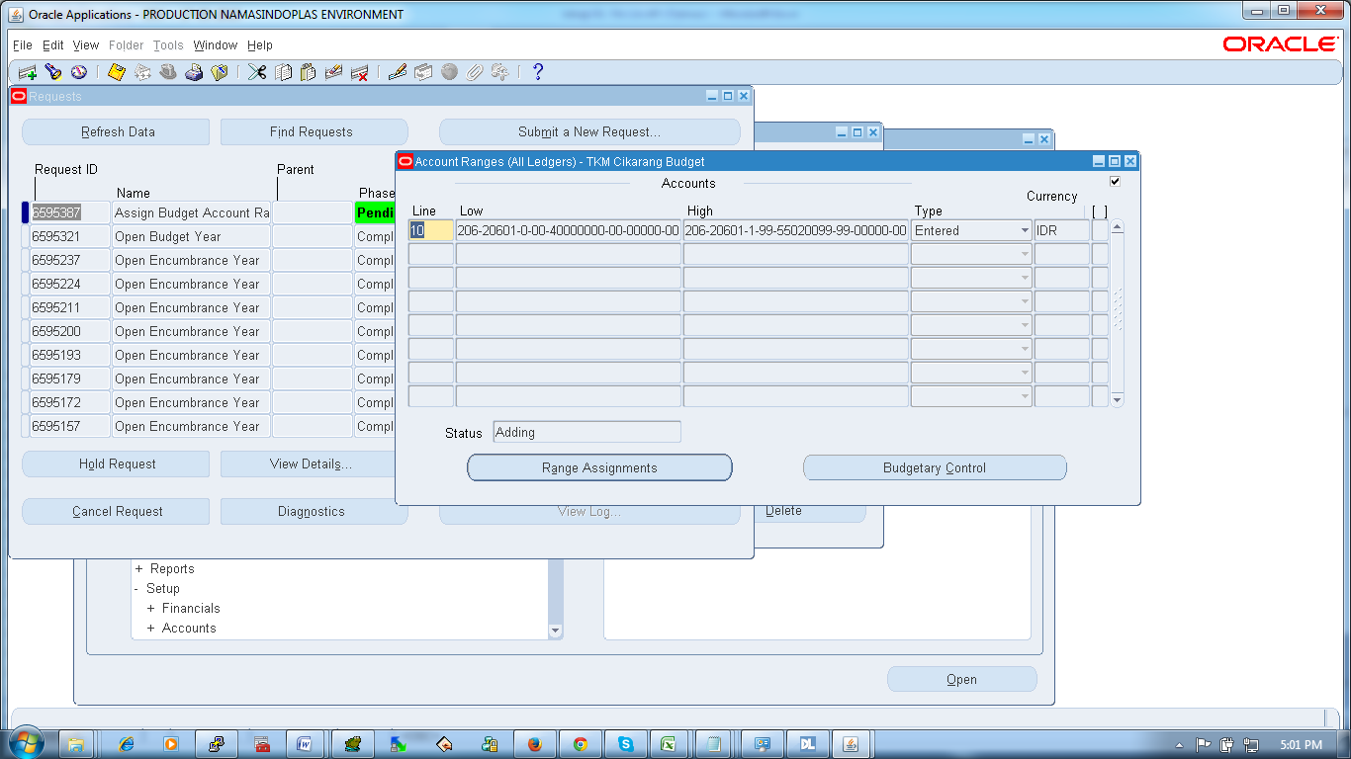

* 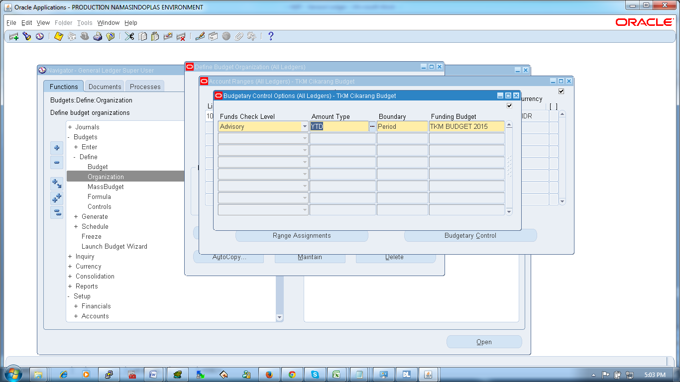
* sdsdsd